## ST JOSEPH’S COLLEGE HUNTERS HILL

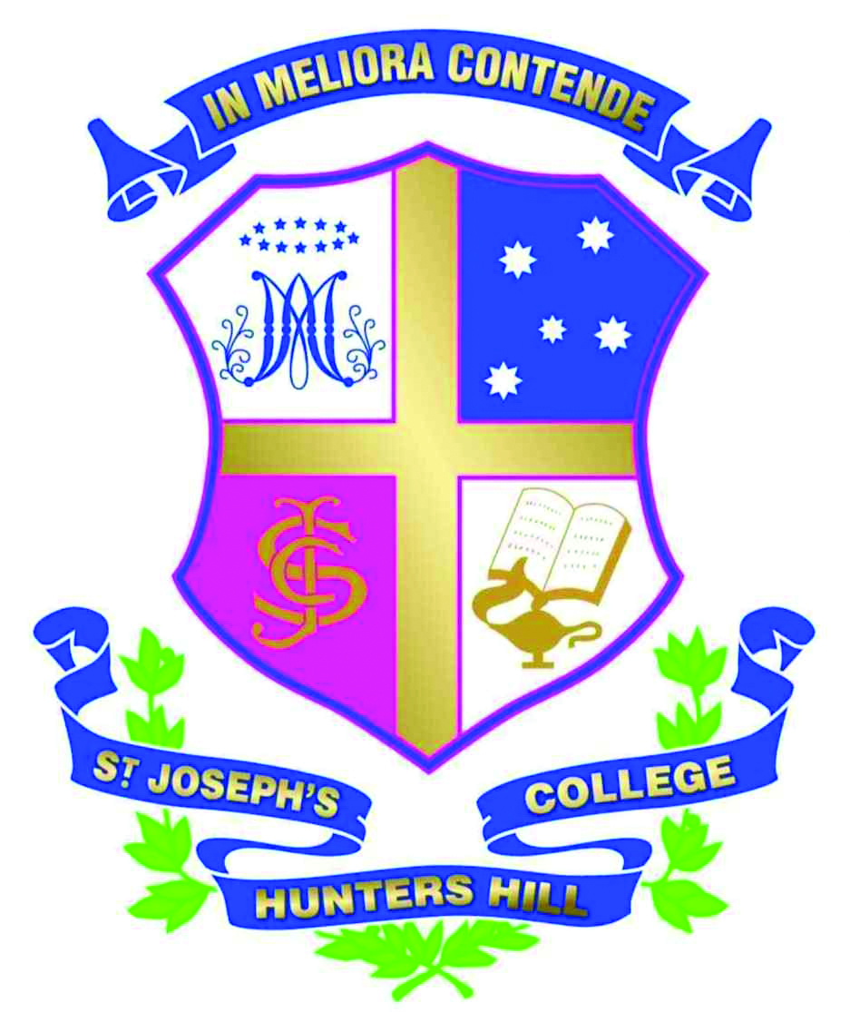

Mark Street, Hunters Hill, NSW 2110 Post: Locked Bag 5009, Gladesville NSW 1675

T: +61 2 9816 0900 F: +61 2 9879 6804

E: sjc@joeys.org W: www.joeys.org

*Philippines Immersion 2018*

*Dear parents and carers,*

*Current Year 10 students (Year 11, 2018) and current Year 11 (Year 12, 2018) are invited to apply to be part of an immersion opportunity to the Philippines.*

*This immersion is a tangible expression of ‘mission’ in the sense that those who participate are undertaking a pilgrimage, an exploration of their own spirituality and place; it will challenge their perception of needs and wants.*

*The immersion will take place at the start of the Easter holidays from 15 - 25 April 2018. Students will be working and living among the street children of Bankeroham in Davao City. The shelter is administered to by the Society of Mary- Marist Fathers and Brothers. The students will also spend some time working at the Badjao School engaged in sporting programs and providing tutoring/educational input.*

*The cost of the trip is approximately $2800 (this will not be confirmed until we can confirm airfares) this includes all facets of the trip including travel, accommodation and meals. A deposit of $500 will be required by October 14th 2017 with the full amount payable by the end of February 2017*

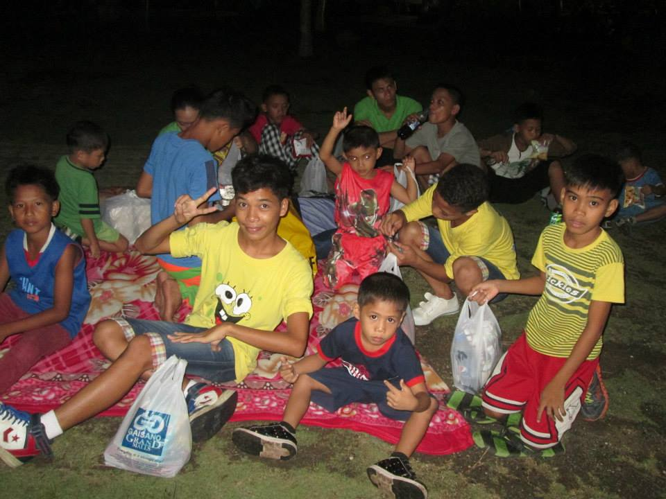

***2***

*For more information please log onto:*[http://www.maristasia.org/](http://l.facebook.com/l.php?u=http%3A%2F%2Fwww.maristasia.org%2F&h=RAQHFH4uy&s=1)

*View the Facebook link:* https://www.facebook.com/pages/Foundation-of-Balay-Pasilungan-Inc/394429530611595

*Application process:*

*It is envisaged that this will be a popular immersion opportunity and as such, if your son is interested, I would ask that he does the following:*

1. *Students will be sent an application in the form of a link; applications will need to be completed no later than 11 September 2017. The following information will need to be included:*

i) *Understanding of what is meant by the Service-Learning Partnership. How does this reflect the teachings of the Catholic faith?*

*ii) Personal reasons for wanting to be part of this immersion opportunity in 2018.*

*iii) The name of one referee and their phone number other than the Boarding Coordinator (Boarding Coordinators will automatically be spoken to). This does not have to be a Joey’s staff member, but of course it can be.*

1. *A short list will be developed based on your written applications.*
2. *Participants in the 2017 visit will be announced by 22 September 2017.*

*If you require further assistance with this process, please email me at* [*lmaher@joeys.org*](mailto:lmaher@joeys.org)

*Many thanks for your interest. I look forward to your son’s application.*

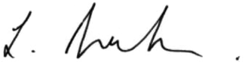

*Lesley Maher*

Director of Mission