Staff Bulletin 10-10-17

Today is World Mental Health Day. The slogan for the 2017 campaign is ‘Do You See What I See?’. This statement is designed to challenge perceptions about mental illness in Australia and encourages everyone to look at mental health in a more positive light, in an effort to reduce stigma and make way for more people to seek the help and support they deserve. For more information on the campaign please visit https://1010.org.au/.

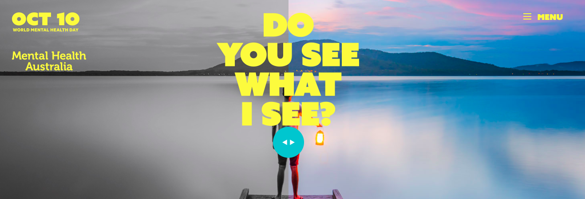

Each year in NSW, Mental Health Month is also celebrated throughout the month of October. The theme for this year is ‘Share the Journey’ which aims to encourage people to connect with each other. Supportive relationships improve our ability to cope with life’s challenges and stressful events. In fact, social connection is a key factor that helps us to develop our resilience. Research tells us that feeling connected, valued and loved by others gives us a sense of security, support, purpose and happiness. Close connections and good relationships with others allows us to enjoy the good times in our lives and helps us deal with the hard experiences we face. Unfortunately, in today’s society we have many demands on our attention and time, and more people experience loneliness in Australia than ever before. For those experiencing or living with mental illness, loneliness can be far worse as individuals can face social exclusion, stigma and discrimination.

These campaigns help us, whether we have a lived experience of mental illness or not, to think about the importance of looking after our mental health and wellbeing. It is a timely reminder to reflect on whether you are practising any of the strategies below for your own self-care. We would like to remind you of the resources available for free to you on the ‘Staff’ section on the iLearn Wellbeing Page and also the EAP service on 1800 81 87 28 or www.accesseap.com.au. The Resources staff have also created a fantastic bookmark for students and one for staff. They have a display in the Resources Centre with some great suggestions of relevant mental health books.

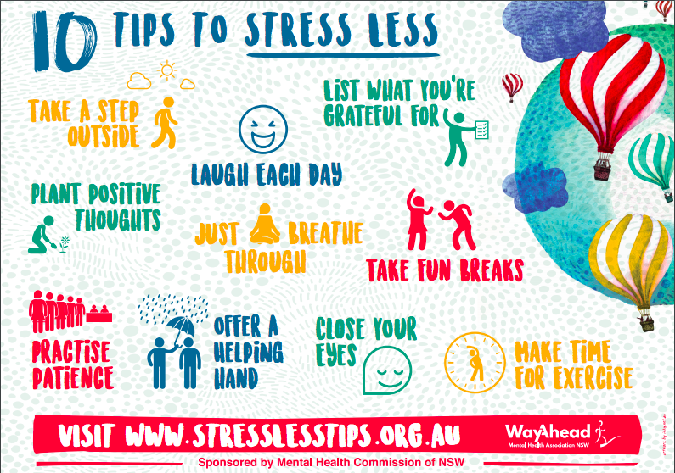

Below are some activities which you could consider using for yourself and/or in your pastoral care group. All of these activities are designed to enhance engagement and find meaning which boost psychological wellbeing.

Tips to stress less: 10 Tips to Stress Less are developed each year for Mental Health Month NSW and distributed throughout the community (see above poster). www.stresslesstips.org.au features a range of evidence-based tips that can help support mental health and wellbeing by decreasing stress. Go to the website and pick a tip to complete daily for a week.

Identify and use your strengths: Think about your strengths and how you might use them in your everyday life. Are you a leader, playful, fair, curious or original? Do you have a good sense of perspective? Do you love learning? Are you genuine? Are you good at teamwork? You can take a free online test on VIA Institute on Character website (www.viacharacter.org) to explore your signature strengths. Cultivate and use your strengths at school, in family life and in your leisure time.

Keep a gratitude diary: Take the time each day to write down three things that went well and why. This causes psychological well-being levels to increase in a lasting way.

Perform small acts of kindness: Performing five kind acts a week, especially all in one day, creates a measurable boost to levels of psychological well-being. Giving not only makes you feel good about yourself, it enhances your connection with others and can bring you positive feedback from others.

Thank a mentor: Write a letter of thanks to someone to who you owe a debt of gratitude such as a friend, teacher or grandparent. Then visit the person and read the letter to them. People who do this are measurably happier for more than a month.

Make a mental health promise: Help shed a more positive light on mental health by making a mental health promise. At home, at school, with family and friends, or in the wider community, we can all do something to help reduce stigma around mental illness and make way for more people to seek the help and support.
Select a suggested promise, or write your own promise. If you write your own, you can upload a photo of yourself or something connected to your promise. There also have a range of images for you to choose from if you prefer. Go to www.1010.org.au/make-a-promise/
