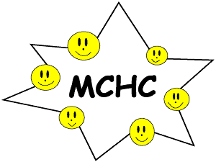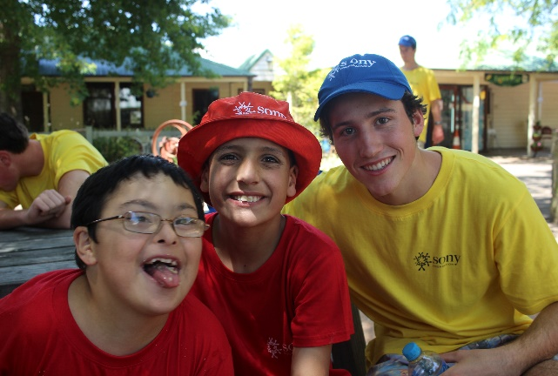

Volunteers needed 2017 Marist Sony Children’s Camp.

The annual Marist Sony Children’s Camp will be held here at the College from 6 – 9 December.

37 children with disabilities will be welcomed to the College by students from Joeys, Marist Sisters Woolwich and Brigidine College. The benefits of the Camp are immeasurable; primarily though the Camp provides much needed respite for the parents of the children with disabilities. Undoubtedly, the students who are involved in the Camp, experience a life changing experience as they step into the role of full time carer of the child that had been entrusted to them.

We are once again reaching out to parents and carers who are able to support the camp. There are a variety of roles available and the link below provides details around roles and dates. We are also keen to hear from any registered nurses who may be able to offer support. If you are able to volunteer please click on the link below. If you have any questions please contact Lesley Maher at: lmaher@joeys.org or call 9816 0898

Many thanks in advance for your support:

http://www.signupgenius.com/go/30e0e4ba9ae2aaafe3-2017

