**National reading hour and the importance of reading**

The Joeys community once again celebrated the importance of reading by participating in National 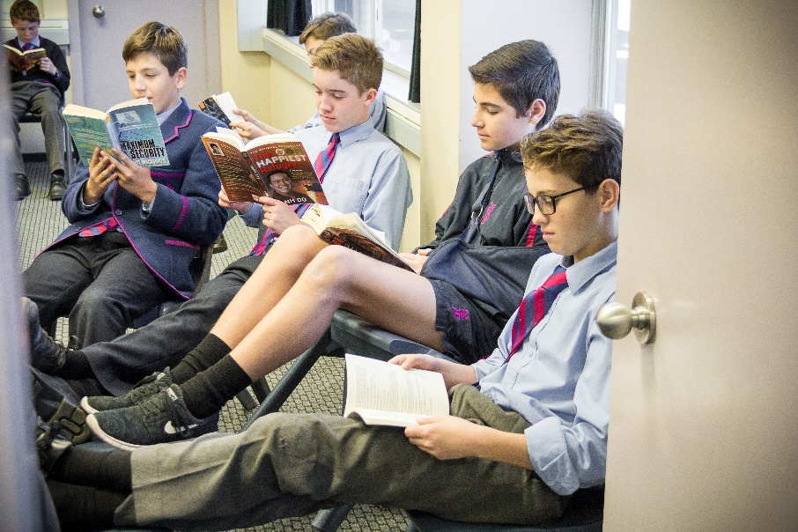Reading Hour. During assembly, the students were informed of several successful leaders who attribute their success to reading. For example, Warren Buffet is an American business magnate, investor, and philanthropist who reads an astounding 200 books per year. When asked about his secret to success, Warren Buffett pointed to a stack of books and said, ***“Read 500 pages like this every day. That’s how knowledge works. It builds up, like compound interest. All of you can do it, but I guarantee not many of you will…”***

It has been calculated that at an average reading speed of 200 words per minute, it would take 850 hours in a year to read 200 books. This sounds like an enormous amount of time, however, when you consider the average Australian teenager spends 650 hours a year on Facebook, 1,450 hours a year online and 1,642 hours watching TV it really comes down to priorities.

We have challenged the boys to start with a **20 Minute Reading Challenge**. By increasing their reading by a mere 20 minutes a day, they will read an additional 1,800,000 words per year, which translates to an astounding 26 novels. All the research demonstrates that reading helps improve your spelling, grammar, comprehension, creative writing skills and places them in the best possible position to achieve success both at school and later in life.

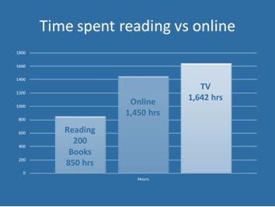

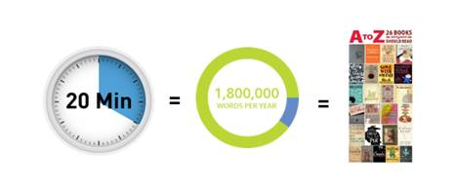

The boys loved the opportunity to immerse themselves in a book during Reading Hour and some of their comments are included below…

“It gave me free time to read a book as I usually struggle to find time to read books.”

“I enjoyed reading hour because I got to just sit down in a quiet classroom and endeavour in a good quality book. I am personally not a fond reader. To be totally honest, I am not fond of reading and will also admit that I went to the library this morning with the intention of just rolling through the book. After 4 pages, I was hooked. I am excited to continue reading this phenomenal book and look forward to getting back into a more sophisticated reading schedule.”

“I loved being able to read for an hour!!!!”

“It relaxed me, with all my assignments coming up and the pressures that brought with it. It was good to take time out and enjoy reading.”

We would love for you to encourage your sons to participate in the 20 minute reading Challenge. For book suggestions please visit our student book review page: [HUB Reviews](http://joeys.libguides.com/TheHUB)

**Linda Roden |** Head of Library **St Joseph's College** **|** Mark Street, Hunters Hill, NSW 2110 **|** Locked Bag 5009, Gladesville, NSW 1675 **T** +61 2 9816 0854 **|** **F** +61 2 9817 1208 **|** E [lroden@joeys.org](mailto:lroden@joeys.org)**|** **W** [www.joeys.org](http://www.joeys.org/)

***St Joseph's College - excellence in boys' education since 1881***

