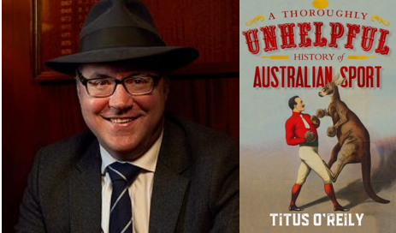**Books & Blokes Breakfast**

**invitation to meet**

**Titus O’Reily**

|  |  |
| --- | --- |
| **When:** | Tuesday 31 October, 2017 |
| **Time:** | 7:30am |
| **Where:** | Resources Centre |
| **RSVP:** | [Click here](https://www.surveymonkey.com/r/TitusOReily) |

We would like to invite you to attend our final Books & Blokes Breakfast for 2017, one which looks to be a most entertaining event.

We began the **Books & Blokes** series at Joeys in 2012 as part of an initiative to celebrate the National Year of Reading. This breakfast series aims to encourage men both at home and in the college community to share their love of reading with the boys, to talk about and recommend books they have enjoyed and to help spread the message that **“It’s OK for Blokes to Read”.** We aim to bring in a broad range of inspirational and interesting speakers to share their stories over a casual and laid back breakfast. (We do not charge students or guests to attend)

**About Titus O’Reily and his new book:**

Part history, part social commentary and part the ravings of a madman, Titus examines:

·      League vs Union, what it says about you as a person

·      Why it’s the AFL’s fault that Victorians are so awful

·      How soccer is the biggest threat to Australia since Communism

·      How cricket, is not boring, OK Sharon?

·      Horse racing, not just about betting but mostly about betting

·      The Olympics or why Australia is only important every four years

Writer and broadcaster Titus O’Reily was born in Melbourne and raised by the Sisters of Collective Misery, a kindly but sombre order who placed an emphasis on sport above all other things, including religion. At the age of eight, Titus set off from Melbourne for London in a rowboat containing only himself and a positive attitude, arriving just two months later thanks to a powerful stroke and favourable currents. Upon returning to Australia, Titus turned to writing about sport, carving out a reputation for inaccuracy and being difficult to work with. Titus’s unique take on sport has been hailed by some of the most respected figures in sport as ‘awful’, ‘childish’ and ‘barely comprehensible’. 
 



Weaving humour and history into one hilarious yet (surprisingly?) informative book, Titus helps us understand how sport is important – gloriously stupid, but important.

**Linda Roden |** Head of Library **St Joseph's College** **|** Mark Street, Hunters Hill, NSW 2110 **|** Locked Bag 5009, Gladesville, NSW 1675 **T** +61 2 9816 0854 **|** **F** +61 2 9817 1208 **|** E [lroden@joeys.org](mailto:lroden@joeys.org)**|** **W** [www.joeys.org](http://www.joeys.org/)

***St Joseph's College - excellence in boys' education since 1881***