EDUCATION PERFECT
All students have access to Education Perfect and need to use it to refine their revision.
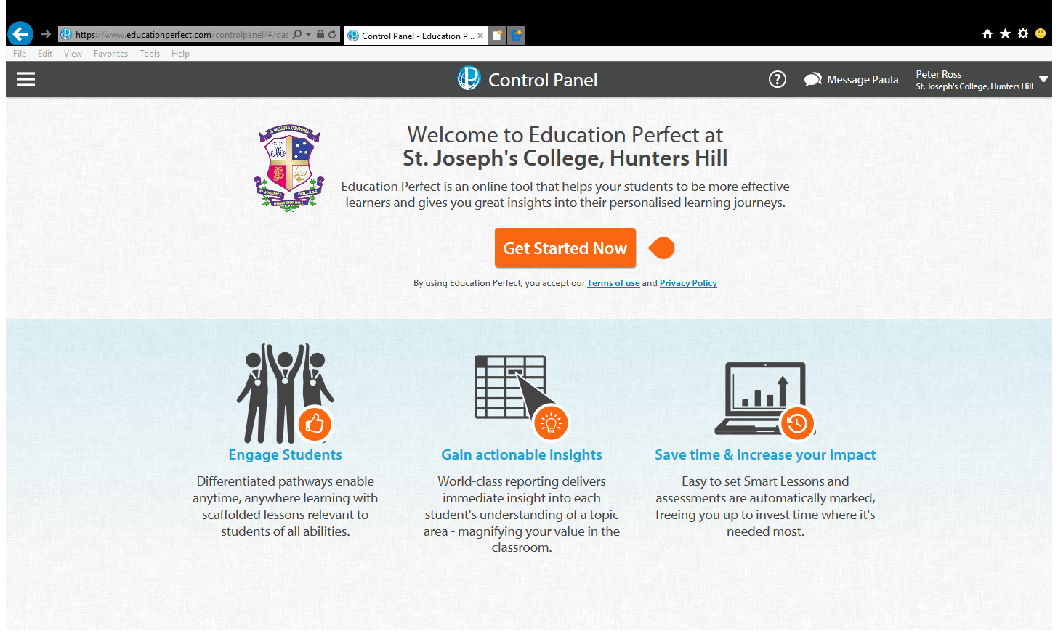

Used by over 300,000 students from 1,000 schools around the world, Education Perfect is a powerful online learning platform for progressive, future ready schools.

Education Perfect is a powerful online learning platform which magnifies the value of a teacher in the classroom - improving learning outcomes and increasing student engagement.
Select a subject to learn more:
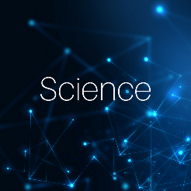 | 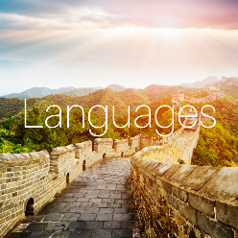 | 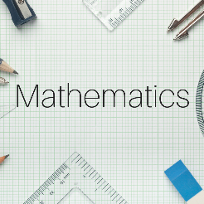 | 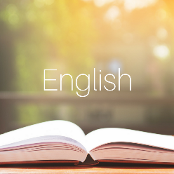
Benefits of the Full Education Perfect Experience:
- Direct integration with many Learning Management Systems
- Single Sign On available
- Full examination features available to schools. This is the same technology used by the New Zealand Qualification Authority to deliver digital Pilot Assessments in 2014, 2015 and 2016.
- Access anywhere, anytime on PC/Laptop/Tablet devices
- Parent reporting
- Live monitoring tells you if students go off task onto other sites/programs
- Spaced repetition
- Content fully customisable
- Full entry to all Education Perfect World Series Events

