From Non-reader to English Teacher
The power of a book to change a life was clearly demonstrated at the latest Guys Read lunch. Books were not part of the childhood world of our guest speaker, Mr. Peter Tucker. Now an enthusiastic English teacher at the College, Mr. Tucker recalled that there were no books in his home and neither his parents nor siblings read much. In Year 5, his teacher encouraged the students to take home a book and recommended he read Mrs. Frisby and the Rats of NIMH, a 1971 Newbery Medal winner by Robert C. O'Brien. So involved in the book was he that remembers actually yelling out “No!” at a point in the story that shocked him. He was taken aback by his strong reaction and realised how powerful books could be, and so became an enthusiastic reader, moving on to the Narnia series and The Hobbit. He now enjoys reading across all genres and makes time to read for about 30 minutes each night.

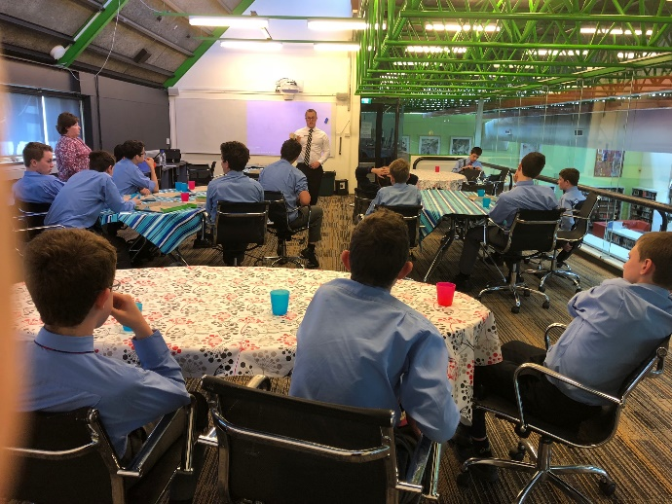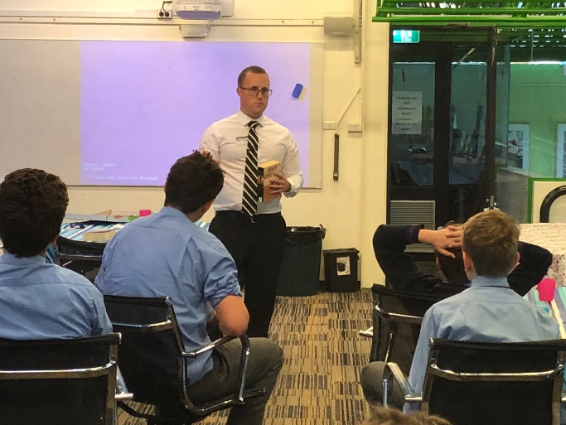

Mr. Tucker brought along a selection of well-loved books from his collection, as well as his current read, Stephen King’s 11.22.63. This novel revolves around an English teacher(!) who stumbles upon a time portal and travels back to three years before John F Kennedy’s assassination. Determined to stop that event, he begins to investigate Lee Harvey Oswald but realises the many implications when you try to change the course of history. Mr. Tucker also enjoyed King’s collection of short stories, Different Seasons, in particular two of these stories that have been made into popular films: The Shawshank Redemption and Stand by Me.
Another favourite is the Game of Thrones fantasy series by George RR Martin. This highly successful series is heavily influenced by English history with the creation of whole worlds, ongoing wars, dragons, complex plots and conspiracies. Mr. Tucker found he developed a deep attachment to the characters, and suggested that you could read these books again and again. In fact, he recommends coming back to books you enjoyed as you always pick up new things; for example, he has read To Kill a Mockingbird by Harper Lee at least six times.
The boys were also intrigued to hear Mr. Tucker’s description of the novel, The Wave, by Morton Rhue which explores the concept of conformity. In this book, a teacher starts a classroom experiment with the intention of showing the students the processes behind social control in Nazi Germany. However, things get out of control and the power of group pressure becomes a frightening reality.
We thank Mr. Tucker for sharing his story of reading, his favourite novels and inspiring the boys to continue their own reading. The Guys Read reading group meet two to three times a term in the library to chat about all things ‘books and reading’ – we encourage any boy who is interested to speak to Mrs. Roden in the library about joining the group.

