Examinations are well underway

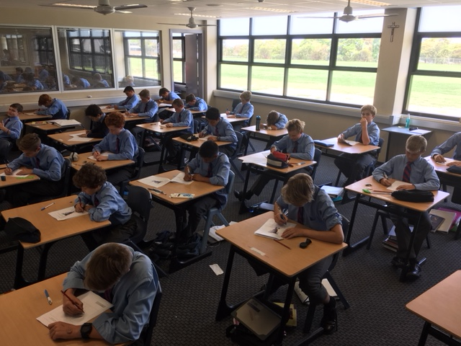

Friday 1st  December | Science  90 + 5 Minutes | Study | PDHPE  60 + 5 Minutes
Monday 4th December | Mathematics  80 + 5 Minutes | Study | Language  75 + 5 Minutes
Tuesday 5th December | Technology  60 + 5 Minutes | Study | History  80 + 5 Minutes

Times indicate the length of the exam
All exams will have 5 minutes Reading Time at the beginning (extra

