“And the Oscar goes to … ”
The Joeys Oscars

Once again, the red carpet was rolled out for our annual Joeys Oscars awards ceremony. These prestigious awards celebrate the best book trailers created by Year 7 students. All students are invited to use iMovie to produce a trailer based on a book they have read and enjoyed, with the main objective being to persuade their fellow students to read the book. With over 90 entries, the trailers demonstrated great creativity, humour and imagination.

At the awards ceremony, nine shortlisted finalists were screened for all Year 7 students and their English teachers to enjoy. The winning team of Daniel Stucci, Benson Mariner and Charles Hine produced a suspenseful and entertaining trailer for the novel, Stormbreaker, by Anthony Horowitz. Coming a close second were Morgan Smith and Daniel Lee for their dramatic trailer promoting the novel, Gone, by Michael Grant. Both teams filmed their own footage using an impressive variety of camera angles and techniques. They also used sound and text creatively to generate interest and build suspense, resulting in excellent trailers that generated maximum interest in the books.

To complement the official awards, we hold the People’s Choice Awards where we invite the student community to view the nine finalists online and vote for their favourite. Interestingly, the winner and runner-up for these awards matched the official judging results, with the most popular trailer being Stormbreaker (Daniel Stucci, Benson Mariner and Charles Hine) and second favourite being Gone (Daniel Lee and Morgan Smith).

All boys are to be congratulated on their fine efforts. To view these trailers click here.

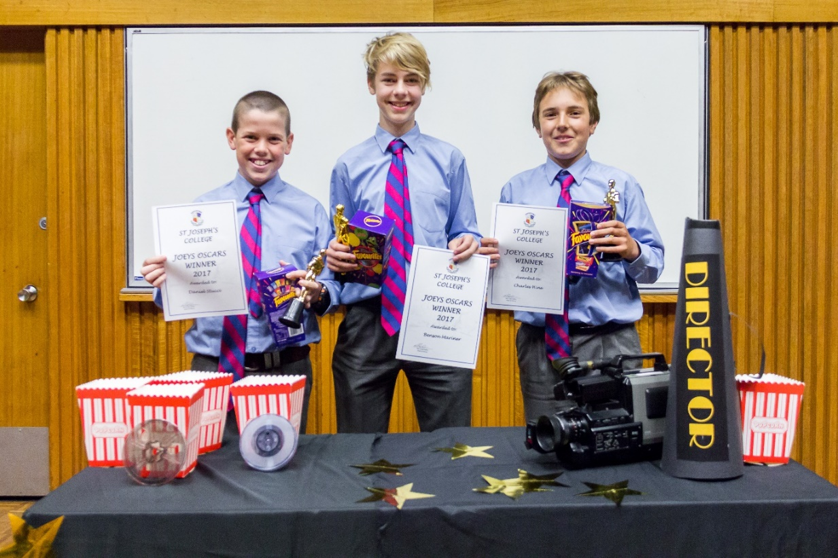
Joeys Oscars Winners – Daniel Stucci, Benson Mariner, Charles Hine all in Year 7

