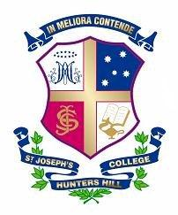
FIXTURES FOR SATURDAY 2nd DECEMBER 2017
BASKETBALL

Team | Opposition | Venue | Time | Bus To | Bus From | Lunch
14A | 14B | SJC Gym | 8:00am
14C | 14D | SJC Outdoor Court 3 | 10:00am
14E | 14F | SJC Outdoor Court 3 | 9:00am

CRICKET v ST PATRICK’S & INTERNALS
Team | Opposition | Venue | Time | Bus To | Bus From | Lunch
14A | 14B | College E | 9.00am – 1.00pm

ROWING
Crew | Activity | Venue | Time | Bus To | Bus From | Lunch
Year 8  (Breakfast 6.30am) | Training | Boat Shed | 7.00am – 11.30am
Year 7  (Breakfast 7:00am) | Training | Boat Shed | 7.30am – 11.30am

TENNIS
Team | Opposition | Venue | Time | Bus To | Bus From | Lunch
14A & B | Internals | SJC 1 – 8 | 10.00am – 12.00pm
14C & D | Internals | SJC 1 – 8 | 10.00am – 12.00pm

WATERPOLO vs GPS (Tom Whalan Cup) & INTERNALS
Team | Opposition | Venue | Time | Bus To | Bus From | Lunch
14A | 14B | College Pool | 8.00am – 9.00am

