“Reading for pleasure is the most important way to advance literacy attainment in children.”
National Literacy Trust UK
Year 7 and Guys Read students, were recently treated to a special presentation about books and reading by Paul McDonald. Paul is the owner of the Children’s Bookshop in Beecroft. He has a Master of Education and worked as a teacher for almost 20 years in Upper Primary and Secondary. He has won numerous awards and in 2012 won the Maurice Saxby Award for his commitment to and contribution to children's literature.
He has a keen interest in Boys’ Literacy and generously gives us his time to promote and encourage reading at Joeys.

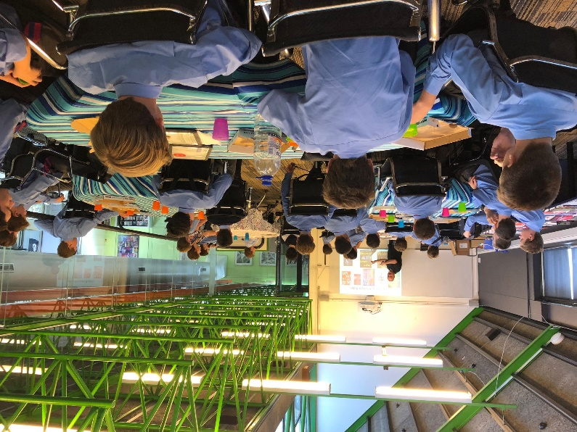

Words of wisdom from Paul:
- Talk about books. Have open discussions with your mates about what you’re reading.
- It important that you read for pleasure and it’s OK to read easy books sometimes
- Now is an important time to step up your reading. Try reading a classic to stretch yourself
- You need to read to become a better writer

Teen Read Trends
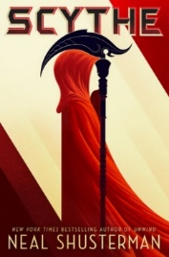 | Scythe by Neal Shusterman is the book at the moment and the book which has generated the most interest amongst Joe boys. Dystopian – set in future – no one dies as medicine is so good. Overpopulation becomes a problem. Now scythes are the only ones who can end life—and they are commanded to do so, in order to keep the size of the population under control.  Citra and Rowan are chosen to apprentice to a scythe—a role that neither wants. These teens must master the “art” of taking life, knowing that the consequence of failure could mean losing their own. Paul says this book is not as confronting as it sounds and says it is a great read.
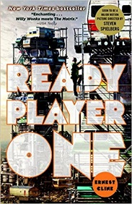 | Ready Player One by Ernest Cline is the hottest book at Joeys at the moment and has recently knocked The Recruit off its perpetual “most popular” book thrown. This is a dystopian futuristic novel where society operates through virtual reality game called The Oasis. A fantastic read for students and parents (lots of 80’s references which make it a great nostalgia trip) and soon to be released movie by Stephen Spielberg. Read this one with your son before the movie comes out.
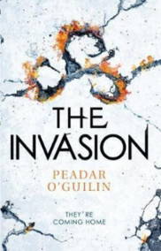 | The Invasion (The Call #2) by Peadar Ó Guilín. The Call was a big hit at Joeys last year and this second book in the series is sure to keep teens interested. Nessa and Anto survived the Call in book one and the authorities believe they made deals with the enemy. Her punishment is to be sent back to the nightmare of the Grey Land for the rest of her life. The Sídhe are waiting, and they have a very special fate planned for her.
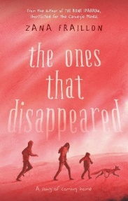 | The ones that disappeared – This novel will win awards. Kept by a ruthless gang, three children manage to escape from slavery. But freedom isn't just waiting on the outside. It’s a powerful tale about three trafficked Syrian children searching for freedom and hope. Across the world, millions of children are the victims of human trafficking. Zana takes an issue that people no doubt think is ‘far away’ and brings it into our hands. The book is set in Australia.
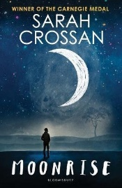 | Moonrise by Sarah Crossan – Year 9 + - A tale of two brothers. One brother is in the US waiting to be executed for murder. The brothers haven’t seen each other for 10 years, but the brother awaiting execution tells his brother he needs to see him before he dies.
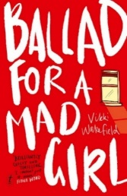 | Ballad for a Mad Girl is an Aussie YA Gothic tale that smartly uses the supernatural to explore the depths of grief and growing up, and the pain to be found in both. It is an intense, unsettling read…Every page is charged with emotion.
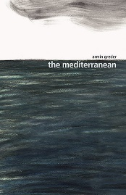 | Mediterranean by Armin Greder is a picture book which depicts the fate of refugees attempting the journey across the Mediterranean. Armin’s books teach us that books can have an immense power and a terrifying ability to make us reflect on who we are and how we behave.
 | If you want to write well, read things that push boundaries such as, Everything is Changed by Nova Weetman, which starts at the end and ends at the beginning. This powerful and gritty novel moves through the wreckage of a broken friendship, back to the moment when everything changed.

