STOP PRESS!!!
The Recuit by Robert Muchamore has lost its ranking as the most popular book at Joeys for the first time in 5 years. (It’s now No. 2)
Ready Player One by Ernest Cline is now our most popular title
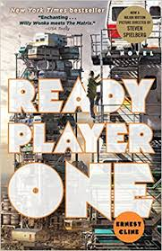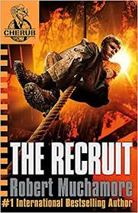

About these books:
The Recuit by Robert Muchamore (Cherub series)
A book about teenage spies - CHERUB agents are intelligent, highly trained, extremely talented--and all under the age of seventeen. For official purposes, these agents do not exist. They are sent out on missions to spy on terrorists, hack into crucial documents, and gather intel on global threats—all without gadgets or weapons. It is an exceptionally dangerous job...
Jo boys love this series!
Ready Player One by Ernest Cline
A dystopian science fiction novel. It's the year 2044, and the real world has become an ugly place. Out of oil. Wrecked climate. Famine, poverty, and disease are widespread. But people have found salvation in the OASIS, an expansive virtual reality universe created by the brilliant and eccentric James Halliday. When Halliday dies, he leaves his immense fortune to the first person to find a digital Easter egg he has hidden somewhere in the OASIS, sparking a contest that grips the entire world.
Stephen Spielberg has made this into a movie. This is a great read and full of nostalgic 80s references.
Read it with your sons!

