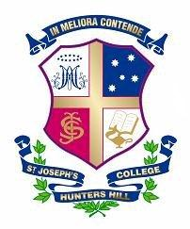
FRIDAY 6th APRIL 2018
DEBATING
Competition | Round | Opposition | Location | Bus To | Bus From
ISDA | 6 | Trinity | SJC
FED | 6 | MLC | MLC | 5.00pm | 8.00pm / 9.00pm

FIXTURES FOR SATURDAY 7th APRIL 2018
RUGBY vs MARIST CANBERRA, SYDNEY BOYS HIGH & RIVERVIEW

Team | Opposition | Venue | Time | Bus To | Bus From | Lunch
13A | Marist Canberra | College C | 12.00pm |  |  | Y9 Ref – 12.30pm
13B v C | Internal Trial | College B | 10.00am |  |  | Y9 Ref – 12noon
13D | SBHS | College C | 9.00am |  |  | Y9 Ref – 12noon
13E | Marist Canberra | College C | 11.00am |  |  | Y9 Ref – 12.30pm
13F v G | Internal Trial | College B | 9.00am |  |  | Y9 Ref – 12noon

CROSS COUNTRY
Host | Venue | Type | Time | Bus To | Bus From | Lunch
WC & SAC | Centennial Park | Comp: 1 | 9.00am | 7.45am | 10.45am | Y9 Ref – 12noon

FOOTBALL vs SCOTS & INTERNALS
Team | Opposition | Venue | Time | Bus To | Bus From | Lunch
13s | Internal Trial | SJC No 3 | 12.00pm |  |  | 1.30pm

TENNIS INTERNALS
Team | Opposition | Venue | Time
Under15s, 14s & 13s | Riverview | SJC Courts 5 - 8 | 8.30am – 10.30am

