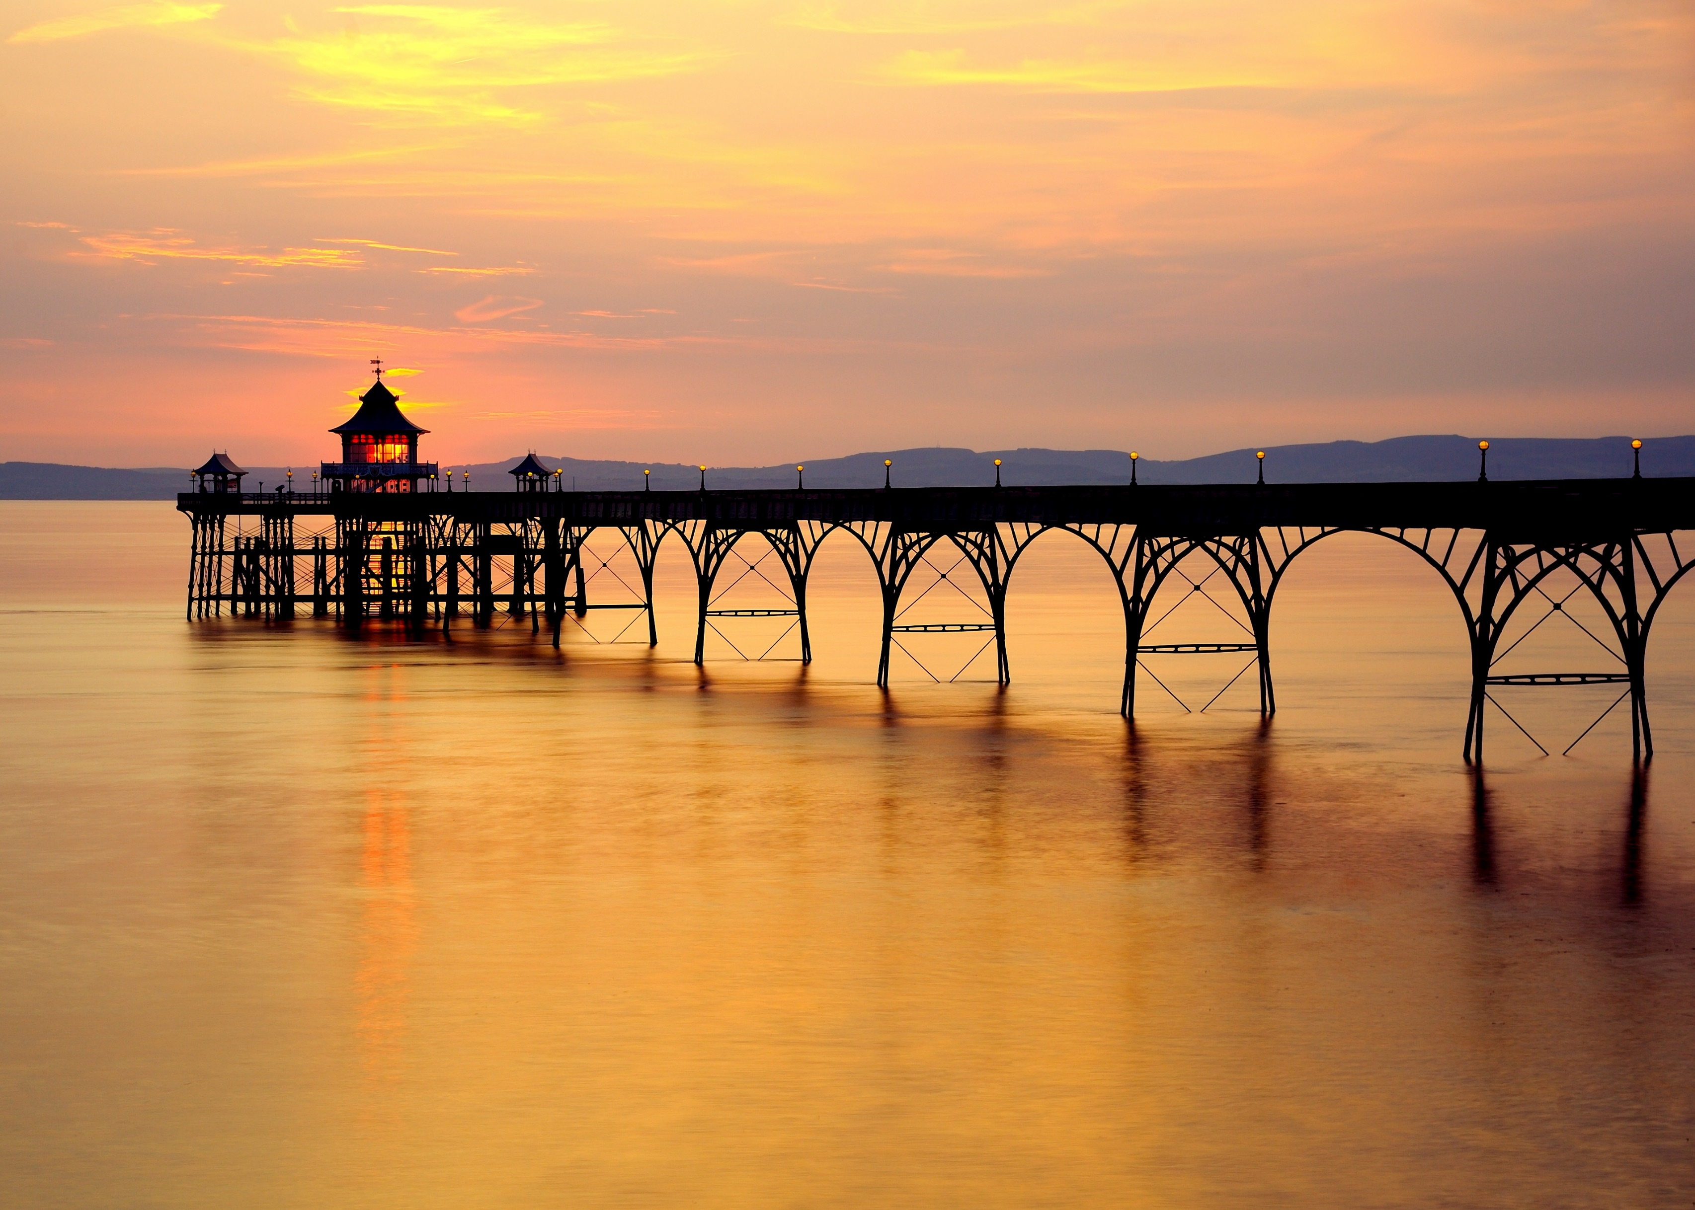

**Friday Morning Mathematics Peer Tutoring**











**# Pier is for illustrative purposes only – there is no water in Room 211 other than the tears of joy when you finally understand that maths work!**

**Friday 8 am to 8:30 am   
Room 211**