Parent Newsletter 24-07-18

Parenting Program: Tuning in to Teens
Starting dates in August
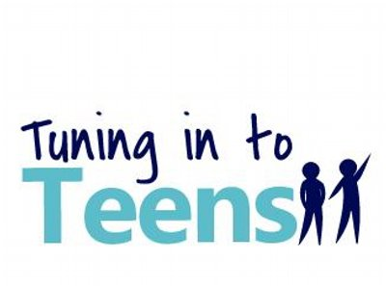
Would you like to learn how to:
• Communicate effectively with your teenager? • Understand your teenager? • Help your teenager with emotional intelligence and managing emotions? • Prevent some teenager behaviour problems? • Teach your teenager to deal with conflict?

Tuning in to Teens™ is a parenting program that focuses on emotions and is designed to assist parents to establish stronger relationships with their teenage children. Tuning in to Teens™ aims to prevent problems developing and enhance emotional and behavioural functioning.

This term the program is being run by Headspace Chatswood and Headspace Brookvale.

See these links for further details:
Chatswood Tuning in to Teens
Brookvale Tuning in to Teens

Free Webinar: Harnessing a Teenager’s Ability to Exert Self-control
8th August 2018 at 7.45pm
Some teenagers need help to know ‘when’ and ‘how’ to apply their mental ‘brakes’. This can be harder to achieve if it’s not practised earlier in a child’s development, but it’s never too late. There are many things that parents can do to maximise a teenager’s restraint ability. To start with, parents need to be able to control three things at home for their teenager’s mind to work best. They need to ensure that a teenager gets enough sleep, that they limit a teenager’s use of technology and that we limit the risks of using drugs or alcohol.
This webinar will address what a parent can do to maximise a teenager’s self-control.

Michael Hawton is the presenter for the webinar. He is a registered psychologist and a former teacher. Michael has authored two books: Talk Less Listen More – solutions for children’s difficult behaviour (2013) and Engaging Adolescents - holding tough conversations with teenagers (2017). His two books have sold over 65,000 copies worldwide and both have been translated into Mandarin.

See this link for more details.

Forum: Mental Health Matters
7th August 2018 at 6pm

The Public Interest Advocacy Centre (PIAC) is holding a public forum at Sydney Grammar School, “Mental Health Matters”, featuring a panel discussion tackling taboos, stigma and discrimination around mental health. The panel will discuss the realities of mental health and mental illness in Australia, and what we can do to provide better care and support for young people and their families.

Speakers
Dr Lisa Pryor (moderator)
Lisa is currently working as a psychiatry registrar in Sydney. She is a contributing opinion writer for The New York Times and a published author of two books. Lisa has degrees in medicine, law and arts from The University of Sydney.

Gus Worland
In addition to being well-known from Sydney’s Triple M Breakfast Show, Gus has established the Gotcha4Life Foundation. Gus is passionate about challenging the old stereotypes of what it means to be a male today in Australia.

Grace White
Driven by her lived experience, Grace is passionate about the social and emotional wellbeing of young people. She has worked as a Youth Advisory Committee Member for Headspace Penrith and is completing her Bachelor of Social Work.

Jonathon Hunyor
Prior to his appointment as CEO of PIAC, Jonathon was the Principal Legal Officer at the North Australian Aboriginal Justice Agency in Darwin and the Director of Legal Services at the Australian Human Rights Commission.

Dr Kristof Mikes-Liu
Dr Mikes-Liu is a child and adolescent psychiatrist and family therapist. He is a clinical lecturer at the University of Sydney, member of the St Vincent’s Open Dialogue Initiative and Asst. Editor for the Australian and NZ Journal of Family Therapy.

See this link for further details.

