**Term 2 - Winter Readers Cup**

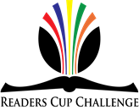Twice a year, our junior students are invited to participate in **The Readers Cup Challenge**. The boys form teams of three students, and spend the next six weeks reading three chosen Readers Cup novels. At the end of the reading period the boys come together to participate in **The Readers Cup Challenge** where they are asked a variety of questions based on these three novels.

**The three novels read by the boys were:**

|  |  |  |
| --- | --- | --- |
| http://d.gr-assets.com/books/1340452076l/15718367.jpg |  |  |
| ***The Disappeared***  by C. J. Harper | ***Cirque Du Freak***  by Darren Chan | ***Ready Player One***  By Ernest Cline |

It was a very tight competition; with no one team dominating and only one point separating the top three places. First place went to Year 8 team **“The Unnamed”** – **Angus Greville, Noah Klugsberger and John Giuliano**. Only 1 point behind wereYear 8 boys; **“Books R Us”** – **Ethan Quintana, Charles Rowley and James Frederikson a**nd who tied with Year 7 boys **“The Leadership” –** Gabriel Phillips, Alexander Phillips and William Perkins.

We also held an individual round with first place awarded to **Angus Greville** in Year 8**.**

It was a fantastic afternoon and all boys did a sensational job. It was a very enjoyable experience for all boys who participated and are congratulated on this fine effort.

Well done boys!

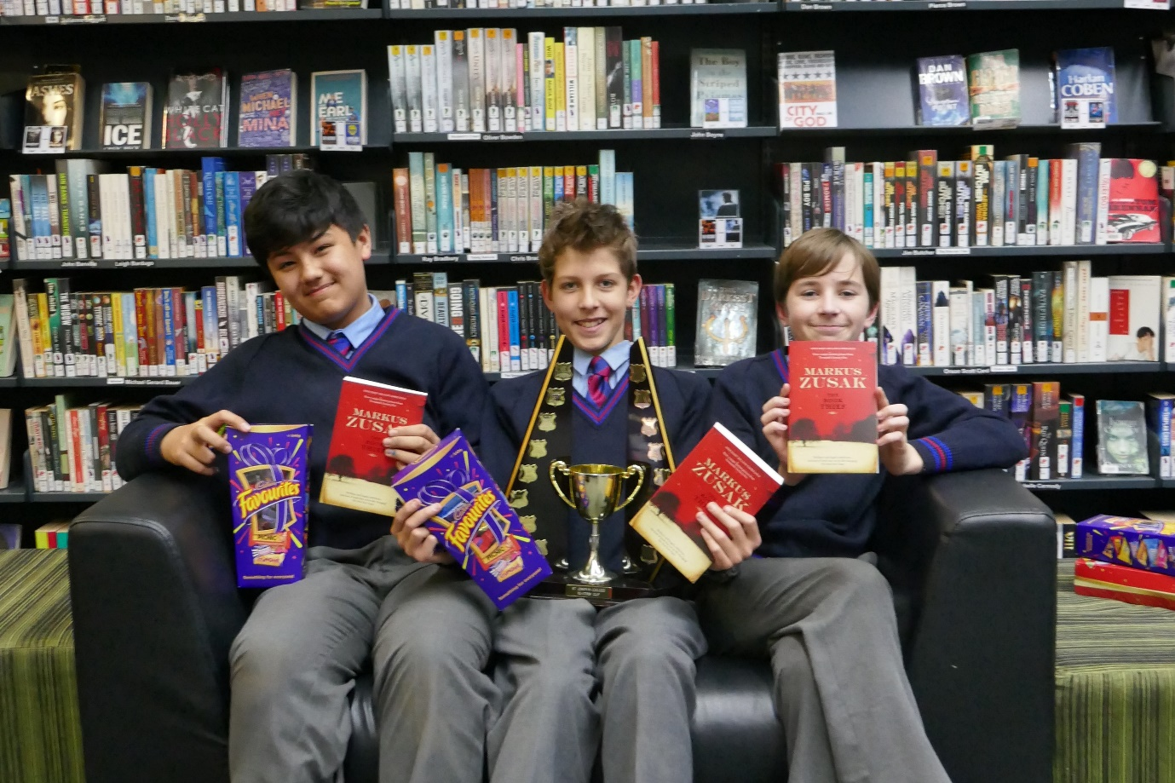

**Readers Cup Champions - John Giuliano, Noah Klugsberger and Angus Greville**

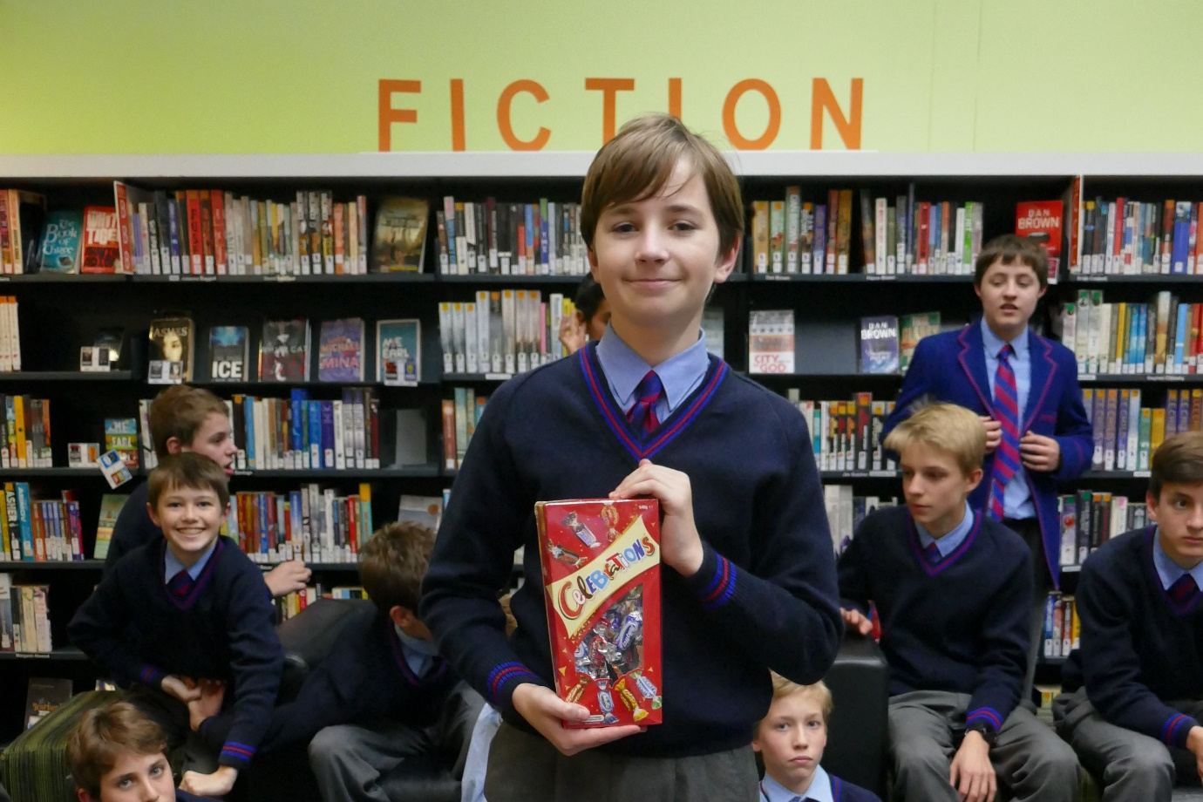

**Individual Round Champion – Angus Greville**

|  |  |
| --- | --- |
| J:\2018\Resources Centre\Winters Readers Cup\Sebastian, Thomas and Otto.JPG | J:\2018\Resources Centre\Winters Readers Cup\Alex, Gabe and Alex .JPG |
| J:\2018\Resources Centre\Winters Readers Cup\Charles Ethan and James.JPG | J:\2018\Resources Centre\Winters Readers Cup\Joshua Coulton and Oliver Baksa.JPG |

