

Officially, this week is Book Week when reading and literacy will be celebrated across Australia. However, we believe that reading should be celebrated and engaged in every day. We focus on creating a culture of reading across the whole community at Joeys including students, staff, and families.

**Creating a culture of reading @ Joeys**

Boys' literacy continues to be a major issue in education nationwide. In many ways, the world has changed for students both at school and home, however, literacy in all its evolving forms has never been more critical for future success and well-being.

**How can we help create a culture of reading?**

* **Set the scene –** Create an environment that encourages reading. Have books and other material visible. Give books as gifts and dedicate regular screen free time for the family.
* **Be a role model –** Teenagers need to see that men read and value reading. Let the your boys see both parents reading and chat to them about it.
* **Make a habit –** Help develop a lifelong habit of reading by encouraging a regular reading time each day. Try the **20 Minute Reading Challenge:** 20 minutes each day = 1,800,000 words = 26 books per year. Everyone can find 20 minutes a day and bedtime is a great time to read.
* **Just Read –** Encourage boys to read what interests them, no matter what form or genre: novels, non-fiction, biographies, blogs, newspapers, magazines, eBooks. All reading helps improve his skills as a reader.
* **Talk about it –**
* Make time to discuss what boys are reading. Praise boys efforts in reading

**A few initiatives we are running include:**

**Books & Blokes with Darren Longbottom and Tim Rushby-Smith**

**A compelling story of mateship, resilience, and coming to terms with the life-changing consequences of riding a single wave.**

The Term 3 Books & Blokes Breakfast took on a new format with author, **Tim Rushby-Smith**, in conversation with ex-pro surfer, **Darren Longbottom**. It was a remarkable event with the audience enthralled with every detail. Our two guests discussed Darren’s childhood at Cronulla surrounded by the world’s elite surfboard riders, his teenage years living at Dapto, and finally his young adult life and a dream surfing safari to Indonesia with a group of mates and subsequent life-changing tragic event.

You could hear a pin drop as Darren read aloud from his book. He talked unflinchly about being at the apex of his life and blissfully happy one minute and fighting for his life the next. The harrowing description of his evacuation from a remote Indonesian Island where so many things went wrong was testament to his will to survive.

Darren is an avid follower of surfing authors, Nick Carroll, Tim Baker and Reggae Ellis, and loves reading surfing books and magazines. Before his accident, if he wasn’t actually surfing Darren said “surfing books consumed my world”. Reading continues to be a passion.

If you would like to watch Darren Longbottom’s talk, it is available on the video service [ClickView](https://clickv.ie/w/aJ4j) using your son’s login. We also have copies of Darren’s book in the library available for loan.

|  |  |
| --- | --- |
| **cid:image013.png@01D4387E.9B7E56D0** | **August 16, 2018_Books & Blokes_Darren Longbottom_2** |
| **August 16, 2018_Books & Blokes_Darren Longbottom_27** | **August 16, 2018_Books & Blokes_Darren Longbottom_19** |

**Villa Maria Kindy Visit**

We will once again host 65 adorable Kindy kids from Villa Maria for book week. Festivities will begin with our Year 9 Drama boys who will perform in the Drama studio. The Kindys will then move to the RC to listen to stories read aloud by our Year 8 literacy boys. Students will also have an opportunity to experience Bots and Virtual Reality with Jeremy Lane and Thea van Os.

**iRead promotion**

We will flood the Resources Centre with various iRead posters.

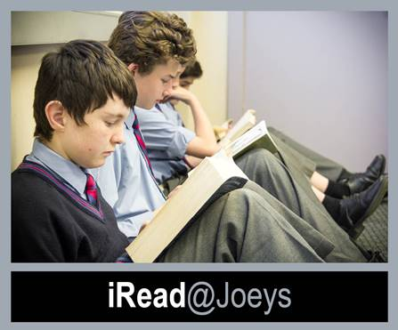

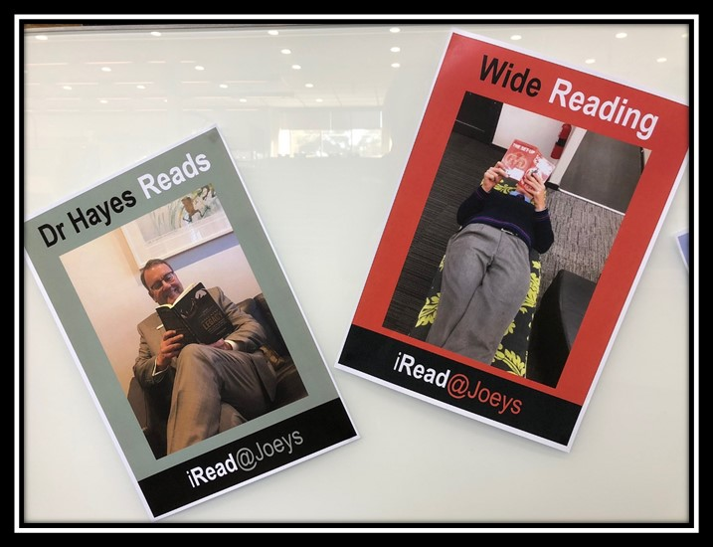

**You’ve Gotta Read This! Promotion**

Students, staff and parents are invited to be filmed discussing one book they feel boys should read. Videos will be 1- 2 minutes long and will include a brief overview of the book followed by the statement “You’ve gotta read this book because…”

If you would like to participate, email [lroden@joeys.org](mailto:lroden@joeys.org) your book review clip. (Ideally have a copy of the book to show during the clip)

**SANTA SABINA YOUTH REVIEW FORUM**

Each year Santa Sabina College hosts the Youth Review Forum, a panel discussion of the shortlisted books for the Children’s Book Council of Australia (CBCA) Book of the Year award. St Joseph’s College is one of three schools invited to participate in the annual forum and this year our panel representatives were Cahn Harbrow (Y10), Cameron Horne (Y10) and Thomas Neate (Y9). The panel members each read four to six books nominated in the Older Readers category, then shared their responses to the novels with the panel and the audience of Year 10 Santa Sabina students.

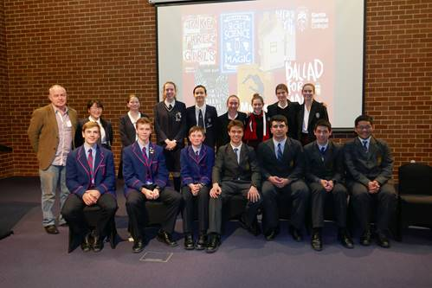

Paul Macdonald and Youth Review Forum panel members

**ARMISTICE DAY**

**THE POPPY PROJECT**

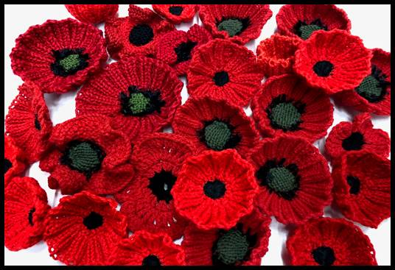

**Gorgeous poppies knitted by the Joeys community**

**On Friday 9 November 2018, SJC Old Boys’ Union will be hosting a mass and luncheon to mark the centenary of Armistice Day.**

**We are bringing together Joeys community to contribute towards “The Poppy Project” display, which involves knitting or crocheting poppies.**

**Target – 3,000**

**If you can knit/crotchet poppies, or know someone who can, we would love you to get involved!**

**Instructions can be found here, but all designs are welcome.** <https://5000poppies.wordpress.com/poppy-patterns/>

* Poppies to be sent into reception or the Resources Centre by the end of Term 3