Pastoral Care Focus:

As discussed earlier in the term, resilience has been a key focus in our pastoral care activities. This week we addressed resilience by focusing on three key areas, these are listed below;

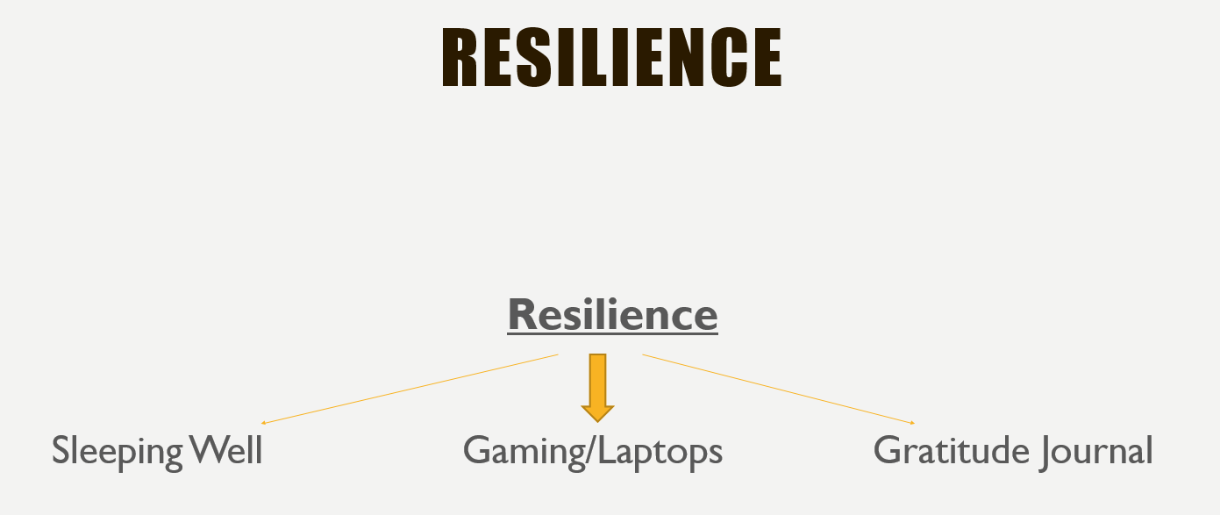

We took the tact that addressing sleeping habits and sleeping well will help the young men become more resilient and act in a more resilient way. We discussed the impact of gaming on sleep along with a few other impacts and introduced a gratitude journal. All these three themes will be focused/discussed during pastoral care lessons daily and aim to build resilience in our young men.
The sleep recommendations and strategies were discussed heavily and the boys were very much encouraged to limit their gaming time. I encourage you to discuss this with your son at home when you can.

