Year 9 Update
Well Week 3 is already upon us and the boys are settling into the routines of Year 9. Summer sport is going along well and the academic pursuits are starting to ramp up. As of this week the boys will go to a full pattern of study each evening. They have been encouraged to use their diaries effectively and to show more initiative in regard to their independent study.

Positivity
Last week at Division Meeting Mr Tucker, the Academic Coordinator launched an initiative around Positivity. Boys whose teachers had nominated them for working hard in class, improved behaviour, involvement etc. had their names placed in a competition where they could win prizes. The aim is to encourage more positive feedback from teachers for the boys and for the boys to see that this feedback is noticed and valued.
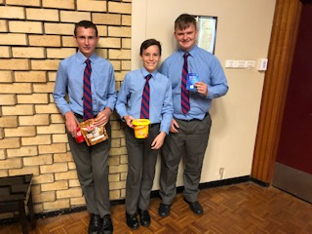
The first winners of Mr Tucker’s Positivity Draw

Academic Awards
Last Thursday at Assembly several boys were recognised for their Academic Application at the end of Year 8. The following boys received Academic Application Awards as a recognition of their hard work and focus. Hopefully this long list bodes well for continued success this year.
Congratulations to:
- Sam Armstrong
- Jackson Basha
- Flynn Costello
- Thomas Dodsworth-Paton
- Angus Dominello
- Thomas Doust
- Sebastian El Droubi
- James Frederikson
- John Giuliano
- Henry Kennedy
- Kristijan Kero
- Xavier Leaver
- Thomas Madden
- Luca Napoli
- Benjamin Price
- Ethan Quintana
- Charles Rowley
- Thomas Summers
- Samuel Turner
- Jack Walkom
- Frederick Ward.

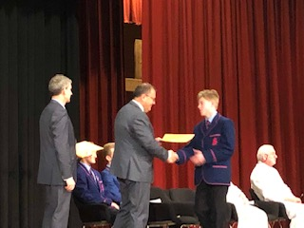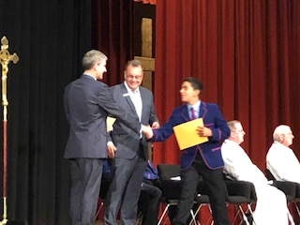

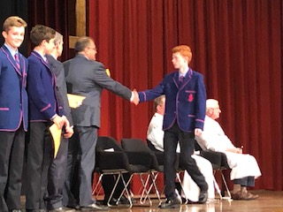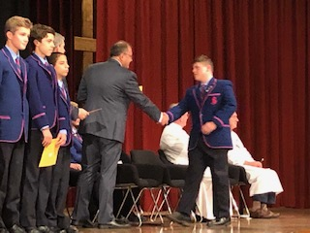

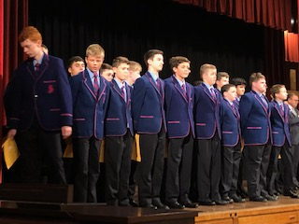
Reading Time
On a normal evening of boarding the boys are generally in bed and the lights are turned off at 9.30 pm. They are then encouraged to use their desk lamps and have 15 minutes of quiet time reading. They can choose to go to sleep or just relax however many boys have been enjoying the opportunity to unwind without a screen for a change.

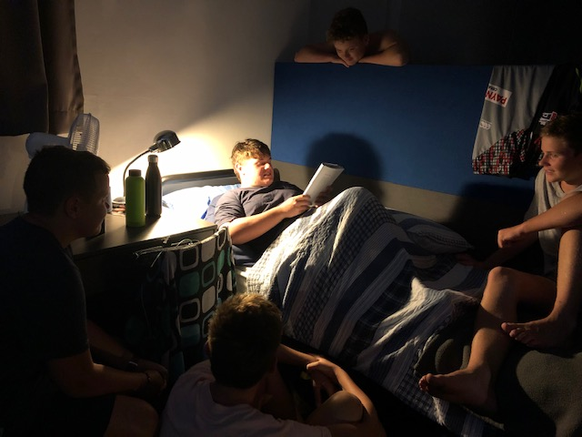

Dorm 8 have taken it a step further with Jack Walkom of Dubbo holding a regular evening “story time.” The boys look forward to Jack’s tales….usually Australian in flavour and full of enthusiasm and animation.

